
NAME: RACHITHA.R
REG-NO: 192421058
SUBJECT: COMPUTER VISION FOR IMAGE SEGMENTATION
SUBJECT-CODE: ITA0528
DATE: 13.03.2026
EXPERIEMNT – 36
Code:
import cv2
import numpy as np
def background_subtraction(image_path):
img = cv2.imread(image_path)
lower = np.array([0, 0, 0])
upper = np.array([100, 100, 100])
mask = cv2.inRange(img, lower, upper)
result = cv2.bitwise_and(img, img, mask=mask)
cv2.imshow("Original", img)
cv2.imshow("Background", result)
cv2.waitKey(0)
cv2.destroyAllWindows()
background_subtraction("image.jpg")
Output:
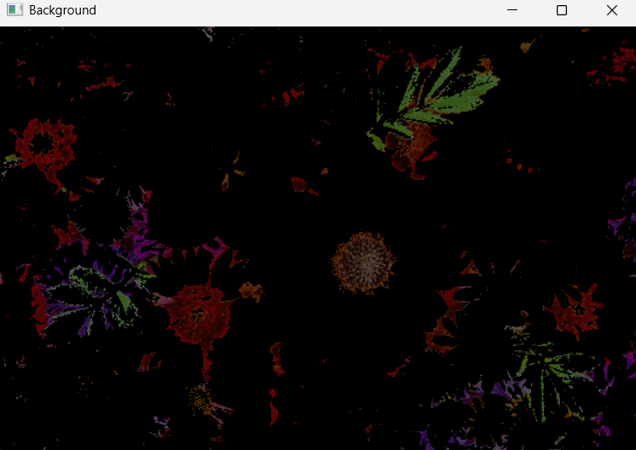
EXPERIMENT – 37
Code:
import cv2
import numpy as np
def foreground_subtraction(image_path):
img = cv2.imread(image_path)
lower = np.array([100,100,100])
upper = np.array([255,255,255])
mask = cv2.inRange(img, lower, upper)
result = cv2.bitwise_and(img, img, mask=mask)
cv2.imshow("Original", img)
cv2.imshow("Foreground", result)
cv2.waitKey(0)
cv2.destroyAllWindows()
foreground_subtraction("image.jpg")
Output:
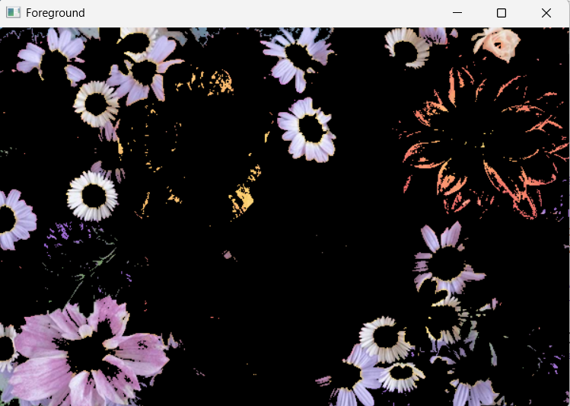

EXPERIMENT – 38
Code:
import cv2
def count_faces(image_path):
img = cv2.imread(image_path)
gray = cv2.cvtColor(img, cv2.COLOR_BGR2GRAY)
face = cv2.CascadeClassifier(cv2.data.haarcascades + "haarcascade_frontalface_default.xml")
faces = face.detectMultiScale(gray, 1.3, 5)
print("Number of faces:", len(faces))
for (x,y,w,h) in faces:
cv2.rectangle(img,(x,y),(x+w,y+h),(0,255,0),2)
cv2.imshow("Faces", img)
cv2.waitKey(0)
cv2.destroyAllWindows()
count_faces("face.jpg")
Output:
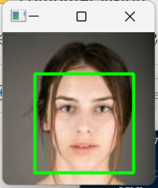

EXPERIMENT – 39
Code:
import cv2
def reverse_video(video_path):
cap = cv2.VideoCapture(video_path)
frames = []
while True:
ret, frame = cap.read()
if not ret:
break
frames.append(frame)
for frame in reversed(frames):
cv2.imshow("Reverse Video", frame)
if cv2.waitKey(100) & 0xFF == 27: # slow motion
break
cap.release()
cv2.destroyAllWindows()
reverse_video("video.mp4")
Output:

EXPERIMENT – 40
Code:
import cv2

def extract_text(video_path):
cap = cv2.VideoCapture(video_path)
while True:
ret, frame = cap.read()
if not ret:
break
gray = cv2.cvtColor(frame, cv2.COLOR_BGR2GRAY)
edges = cv2.Canny(gray, 50, 150)
contours, _ = cv2.findContours(edges, cv2.RETR_EXTERNAL, cv2.CHAIN_APPROX_SIMPLE)
for c in contours:
x, y, w, h = cv2.boundingRect(c)
if w > 50 and h > 20:
cv2.rectangle(frame, (x,y), (x+w,y+h), (0,255,0), 2)
cv2.imshow("Text Detection", frame)
if cv2.waitKey(30) & 0xFF == 27:
break
cap.release()
cv2.destroyAllWindows()
extract_text("video.mp4")

